|  |
| --- |
| C:\Users\CHAYAPATHI-CPN\Desktop\download.png  **Department of Information Science and Engineering** |
| **Acharya Institute of Technology** |
| Acharya Dr. Sarvepalli Radhakrishnan Road, Bangalore-560107 |

|  |  |  |  |  |  |
| --- | --- | --- | --- | --- | --- |
| **WEEKLY PROGRESS REPORT** | | | | | |
| **Batch No** | | **Batch-5** | | | |
| **Guide** | |  | | | |
| **Project Title** | | **IOT based wireless smart board** | | | |
| **Progress Report No** | | **2** | | | |
| **Date of Submission** | | **02 Nov 2018** | | | |
| **Date** | | **From: 26 Oct 2018** | | | **To:02 Nov 2018** |
|  | | | | | |
| **Sl. No.** | **Student Name** | | **USN** | **Signature with date** | |
| **1** | Pravesh Kasaundhan | | **1AY15IS072** |  | |
| **2** |  | |  |  | |
| **3** |  | |  |  | |
| **4** |  | |  |  | |
|  | | | | | |
|  | | | | | |

Progress:

* We have found that online portals i.e. **Dataplicity** would be the best portal among others to access Raspberry-pi. This portal is needed to give straightforward terminal access to devices on remote cellular, satellite and fixed line networks.
* **Dataplicity** is essentially a VPN for you Raspberry-Pi. It not only lets you connect to your Pi remotely but you can also can “wormhole” a web server through the system, allowing you to run a mini website from the comfort of your computer**.**
* **Steps to install Raspbian OS on raspberry pi3:**

### Step 1: Download Raspbian

**[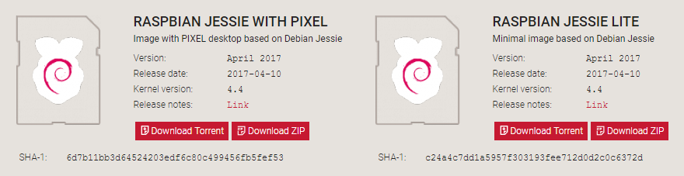](https://thepi.io/wp-content/uploads/2017/05/raspbian-download.png)**

First things first: hop onto your computer (Mac and PC are both fine) and download the Raspbian disc image.  Give yourself some time for this, especially if you plan to use the traditional download option rather than the torrent. It can easily take a half hour or more to download.

### Step 2: Unzip the file

The Raspbian disc image is compressed, so you’ll need to unzip it. The file uses the ZIP64 format, so depending on how current your built-in utilities are, you need to use certain programs to unzip it. If you have any trouble, try these programs recommended by the Raspberry Pi Foundation

### Step 3: Write the disc image to your microSD card

**[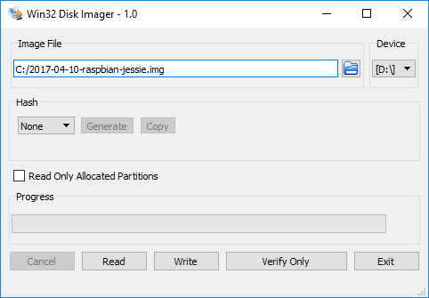](https://thepi.io/wp-content/uploads/2017/05/win32-disk-imager-raspbian.png)**

Next, pop your microSD card into your computer and write the disc image to it. You’ll need a specific program to do this:

* Windows users - [**Win32 Disk Imager**](https://sourceforge.net/projects/win32diskimager/)**.**
* Mac users, you can use the disk utility that’s already on your machine.
* Linux users - [**Etcher**](https://etcher.io/) – which also works on Mac and Windows – is what the Raspberry Pi Foundation recommends.

The process of actually writing the image will be slightly different across these programs, but it’s pretty self-explanatory no matter what you’re using. Each of these programs will have you select the destination (make sure you’ve picked your microSD card!) and the disc image (the unzipped Raspbian file). Choose, double-check, and then hit the button to write.

### Step 4: Put the microSD card in your Pi and boot up

Once the disc image has been written to the microSD card, you’re ready to go! Put that sucker into your Raspberry Pi, plug in the peripherals and power source, and enjoy. The current edition to Raspbian will boot directly to the desktop. Your default credentials are username **pi** and password **raspberry.**

* We bought **Raspberry Pi 3 Model B**
* Brand name – Raspberry Pi
* Item model number – RASPBERRYPI3-MODB-1GB
* Operating System – Raspbian
* Screen size – 60 inches
* Processor – 1.2GHz
* RAM – 1 GB SDRAM DDR3
* Wireless Type – 802.11bgn
* Number of USB 0.2 ports – 4
* Processor count – 4
* Batteries – 3 9V batteries required

Work schedule and expected result for the next week

* We went through the basics of python libraries and we are planning to learn the implementation of these libraries for our project.
* We will learn about the assembly and connection of the components.

References:

* www.raspbian.org
* www.python.org
* [www.raspberrypi.org](http://www.raspberrypi.org)
* [www.dataplicity.com](http://www.dataplicity.com)
* <https://www.youtube.com/watch?v=6E9n71zeETE>
* <https://www.youtube.com/watch?v=9rE_XLX-z60>

Guide Project Coordinator HOD-ISE

(Signature With Date) (Signature With Date) (Signature With Date)